Skip to content
Navigation Menu
- Platform

- Solutions

- Resources

- Open Source

- Enterprise

- Pricing
Search or jump to...
Sign in
Sign up
SAGAR-TAMANG/friday-tony-stark-demoPublic

- Code
- Issues
- Pull requests3
- Actions
- Projects
- Security and quality
- Insights
SAGAR-TAMANG/friday-tony-stark-demo
Name
SAGAR-TAMANG
chore(README): add youtube link
370bee7 · last week
friday | feat: add tool openworldmonitor | last week
.env.example | feat: add readme | last week
.gitignore | feat: initial commit | last week
.python-version | feat: initial commit | last week
README.md | chore(README): add youtube link | last week
agent_friday.py | feat: convert groq -> gemini api key | last week
main.py | feat: initial commit | last week
pyproject.toml | feat: convert groq -> gemini api key | last week
server.py | fix: make server.py work | last week
uv.lock | feat: convert groq -> gemini api key | last week
Repository files navigation
- README
F.R.I.D.A.Y. — Tony Stark Demo
"Fully Responsive Intelligent Digital Assistant for You"
A Tony Stark-inspired AI assistant split into two cooperating pieces:
Component | What it is
MCP Server (uv run friday) | A FastMCP server that exposes tools (news, web search, system info, …) over SSE. Think of it as the Stark Industries backend — it does the actual work.
Voice Agent (uv run friday_voice) | A LiveKit Agents voice pipeline that listens to your microphone, reasons with an LLM (Gemini 2.5 Flash by default), and speaks back with OpenAI TTS — all while pulling tools from the MCP server in real time.
Demo: Instagram reel
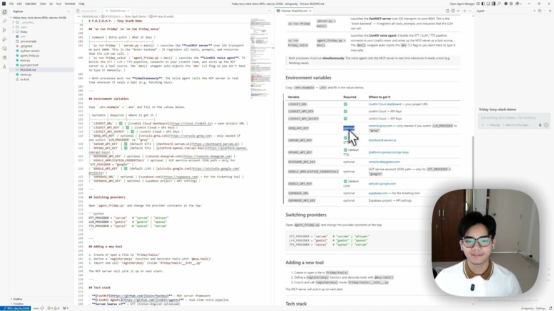

How it works
Microphone ──► STT (Sarvam Saaras v3)
│
▼
LLM (Gemini 2.5 Flash) ◄──────► MCP Server (FastMCP / SSE)
│ ├─ get_world_news
▼ ├─ open_world_monitor
TTS (OpenAI nova) ├─ search_web
│ └─ …more tools
▼
Speaker / LiveKit room
The voice agent connects to the MCP server via SSE at http://127.0.0.1:8000/sse (auto-resolved to the Windows host IP when running inside WSL).

Project structure
friday-tony-stark-demo/
├── server.py # uv run friday → starts the MCP server (SSE on :8000)
├── agent_friday.py # uv run friday_voice → starts the LiveKit voice agent
├── pyproject.toml
├── .env.example # copy → .env and fill in your keys
│
└── friday/ # MCP server package
├── config.py # env-var loading & app-wide settings
├── tools/ # MCP tools (callable by the LLM)
│ ├── web.py # search_web, fetch_url, get_world_news, open_world_monitor
│ ├── system.py # get_current_time, get_system_info
│ └── utils.py # format_json, word_count
├── prompts/ # MCP prompt templates (summarize, explain_code, …)
└── resources/ # MCP resources exposed to clients (friday://info)

Quick start
1. Prerequisites
- Python ≥ 3.11
- uv — pip install uv or curl -Lsf https://astral.sh/uv/install.sh | sh
- A LiveKit Cloud project (free tier works)
2. Clone & install
git clone https://github.com/SAGAR-TAMANG/friday-tony-stark-demo.git
cd friday-tony-stark-demo
uv sync # creates .venv and installs all dependencies
3. Set up environment
cp .env.example .env
# Open .env and fill in your API keys (see the section below)
4. Run — two terminals
Terminal 1 — MCP server (must start first)
uv run friday
Starts the FastMCP server on http://127.0.0.1:8000/sse. The voice agent connects here to fetch its tools.
Terminal 2 — Voice agent
uv run friday_voice
Starts the LiveKit voice agent in dev mode — it joins a LiveKit room and begins listening. Open the LiveKit Agents Playground and connect to your room to talk to FRIDAY.

uv run friday vs uv run friday_voice
Command | Entry point | What it does
uv run friday | server.py → main() | Launches the FastMCP server over SSE transport on port 8000. This is the "brain backend" — it registers all tools, prompts, and resources that the LLM can call.
uv run friday_voice | agent_friday.py → dev() | Launches the LiveKit voice agent. It builds the STT / LLM / TTS pipeline, connects to your LiveKit room, and wires up the MCP server as a tool source. The dev() wrapper auto-injects the dev CLI flag so you don't have to type it manually.
Both processes must run simultaneously. The voice agent calls the MCP server in real time whenever it needs a tool (e.g. fetching news).

Environment variables
Copy .env.example → .env and fill in the values below.
Variable | Required | Where to get it
LIVEKIT_URL | ✅ | LiveKit Cloud dashboard → your project URL
LIVEKIT_API_KEY | ✅ | LiveKit Cloud → API Keys
LIVEKIT_API_SECRET | ✅ | LiveKit Cloud → API Keys
GROQ_API_KEY | optional | console.groq.com — only needed if you switch LLM_PROVIDER to "groq"
SARVAM_API_KEY | ✅ (default STT) | dashboard.sarvam.ai
OPENAI_API_KEY | ✅ (default TTS) | platform.openai.com/api-keys
DEEPGRAM_API_KEY | optional | console.deepgram.com
GOOGLE_APPLICATION_CREDENTIALS | optional | GCP service-account JSON path — only for STT_PROVIDER = "google"
GOOGLE_API_KEY | ✅ (default LLM) | aistudio.google.com
SUPABASE_URL | optional | supabase.com — for the ticketing tool
SUPABASE_API_KEY | optional | Supabase project → API settings

Switching providers
Open agent_friday.py and change the provider constants at the top:
STT_PROVIDER = "sarvam" # "sarvam" | "whisper"
LLM_PROVIDER = "gemini" # "gemini" | "openai"
TTS_PROVIDER = "openai" # "openai" | "sarvam"

Adding a new tool
- Create or open a file in friday/tools/
- Define a register(mcp) function and decorate tools with @mcp.tool()
- Import and call register(mcp) inside friday/tools/__init__.py
The MCP server will pick it up on next start.

Tech stack
- FastMCP — MCP server framework
- LiveKit Agents — real-time voice pipeline
- Sarvam Saaras v3 — STT (Indian-English optimised)
- Google Gemini 2.5 Flash — LLM
- OpenAI TTS (nova voice) — TTS
- uv — fast Python package manager

License
MIT
About
Demo of tools of capabilities of Tony Stark.
Resources
Readme
Activity
Stars
678 stars
Watchers
13 watching
Forks
232 forks
Report repository
Releases
No releases published
Packages
No packages published
Contributors1
- SAGAR-TAMANG Sagar Tamang
Languages
- Python100.0%
Footer
© 2026 GitHub, Inc.
Footer navigation
- Terms
- Privacy
- Security
- Status
- Community
- Docs
- Contact
- Manage cookies
- Do not share my personal information

